[Skip to content](https://www.techsmith.com/blog/instructional-videos/" \l "content)

* [Products](https://www.techsmith.com/products.html)
* [Solutions](https://www.techsmith.com/solutions.html)
* [Support](https://www.techsmith.com/help.html)
* [Resources](https://www.techsmith.com/company.html)

* [About](https://www.techsmith.com/about.html)
* [Store](https://www.techsmith.com/products.html)

Top of Form

Search TechSmith.comSearch TechSmith.com

Bottom of Form

* [**Home**](https://www.techsmith.com/blog/)
* [**Video**](https://www.techsmith.com/blog/category/video/)
* [**Visuals**](https://www.techsmith.com/blog/category/visuals/)
* [**Screen Capture & Recording**](https://www.techsmith.com/blog/category/capture-and-recording/)
* [**Research & Guides**](https://www.techsmith.com/blog/instructional-videos/)
* [**In the Media**](https://www.techsmith.com/blog/category/in-the-media/)

**The Ultimate Guide to Easily Make Instructional Videos**

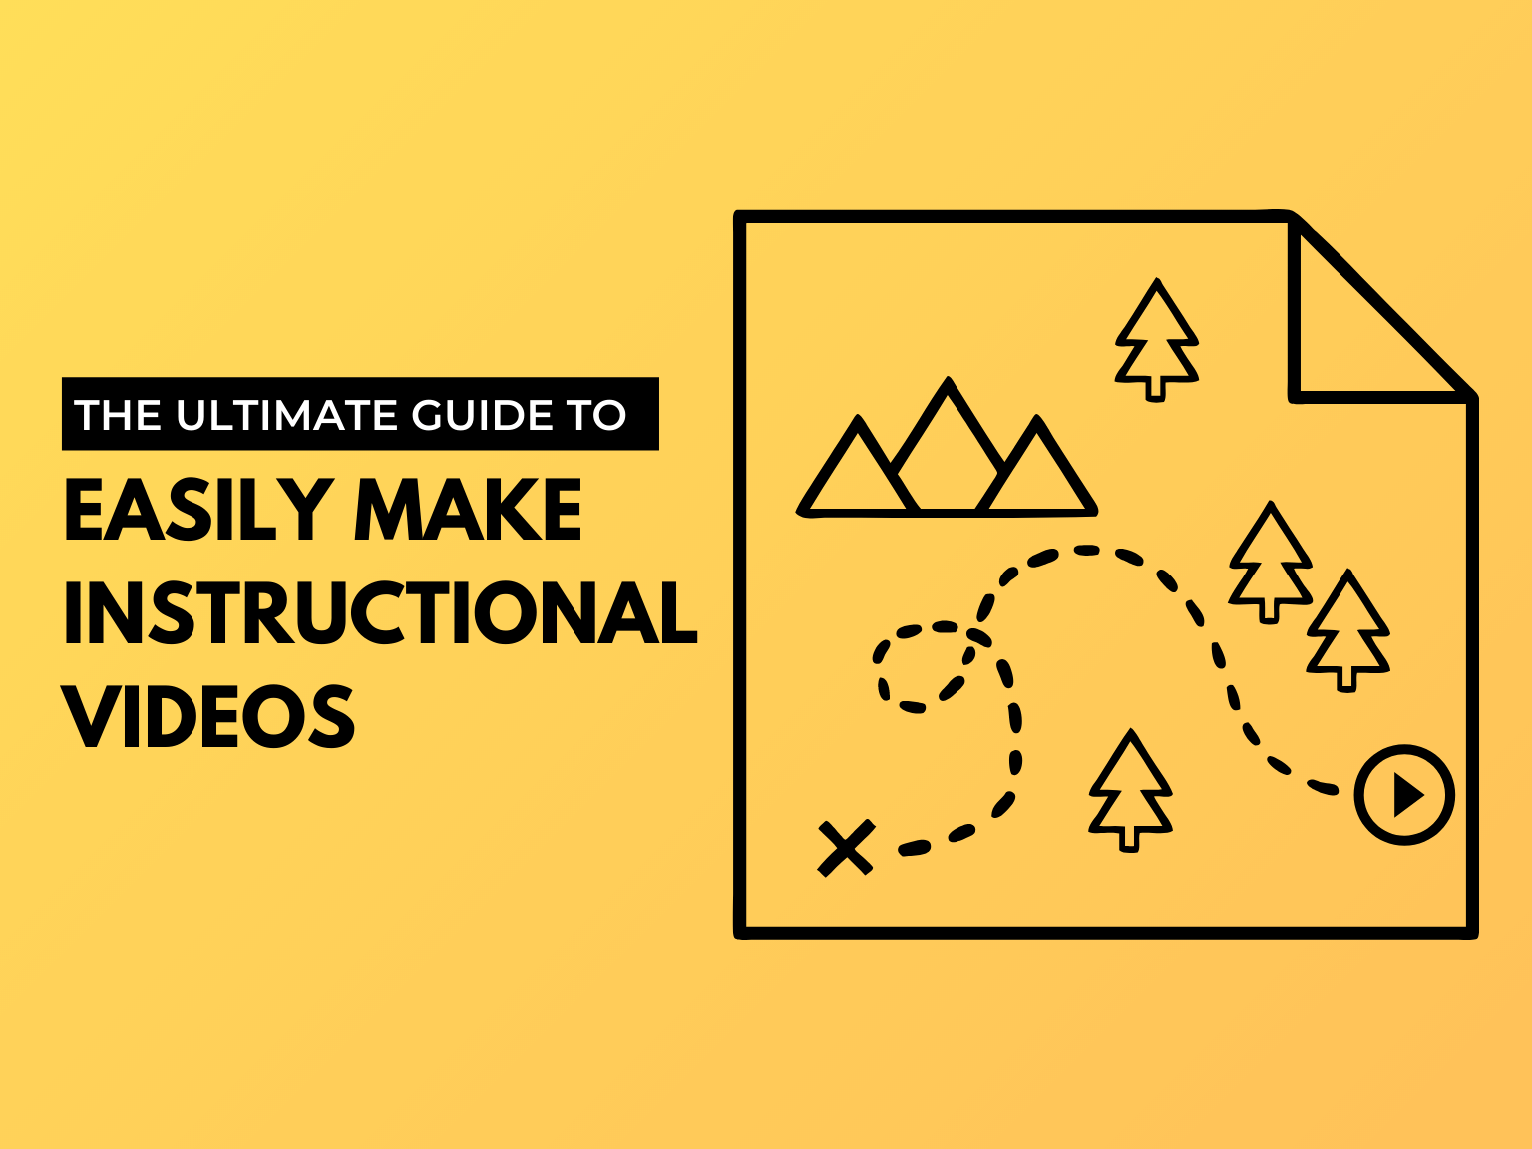

When you need to learn something new, what do you do? You probably look for a video. And you’re not alone.

Regardless of your industry, if you’re serious about teaching others, growing your business, or building an online course, instructional videos are the best delivery method.

Research shows that when people look for answers to their questions, they prefer to consult a video. In fact:

* [83% of people prefer watching videos](https://www.techsmith.com/blog/video-statistics/) to accessing instructional or informational content via text or audio.
* More than half of [online shoppers say they use video](https://www.thinkwithgoogle.com/marketing-strategies/video/in-store-video-shopping-behavior/) to help make purchase decisions.
* Two out of three employees complete tasks better when instructions are provided visually and [absorb information 7% faster.](https://www.techsmith.com/visual-communication-research.html)
* More than [70% of YouTube viewers turn to the platform for help](https://www.thinkwithgoogle.com/marketing-strategies/video/self-directed-learning-youtube/) solving problems.

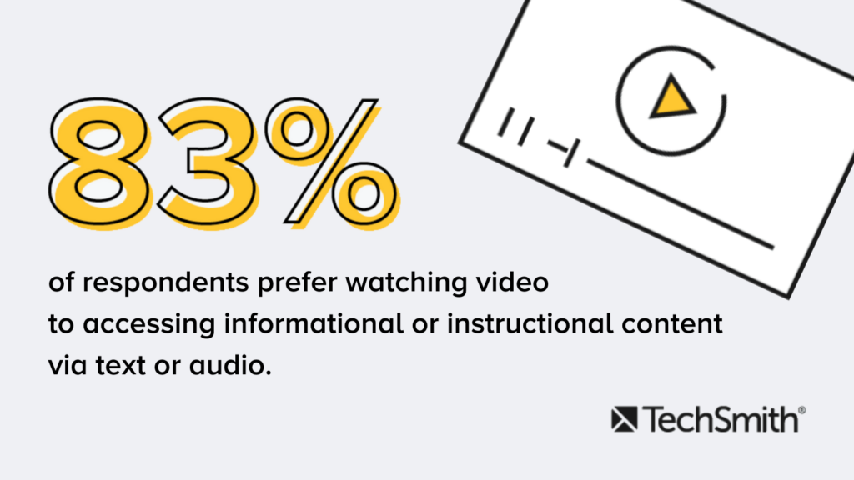[New Research | Video Statistics, Habits, and Trends You Need to Know](https://www.techsmith.com/blog/video-statistics/)

**You may be wondering, “how do I create online training videos?”**

It can be a challenge for many small businesses, educators, and entrepreneurs to find the time to create video content.

That’s why we’re here to help! It’s much easier than you might think.

This guide will share the secrets to easily creating high-quality training and tutorial videos.

We know what works (and what doesn’t), and we’ll show you exactly what to do to make how-to and instructional videos.

**Make your own instructional videos today!**

Download Camtasia and FREE templates to quickly and easily make your own tutorial and training videos.

[Download](https://www.techsmith.com/template-instructional-video.html)

**Here’s what you’ll learn in this free guide to creating great instructional videos:**

* [The most popular types of instructional videos](https://www.techsmith.com/blog/instructional-videos/#h-what-is-an-instructional-video)
* [Common mistakes people make when creating instructional videos](https://www.techsmith.com/blog/instructional-videos/#h-common-mistakes-people-make-when-creating-videos)
* [The best software for making instructional videos](https://www.techsmith.com/blog/instructional-videos/#h-the-best-software-for-making-instructional-videos)
* [How to make an instructional video in 7 steps](https://www.techsmith.com/blog/instructional-videos/#h-how-to-make-an-instructional-video)
* [The actual cost of making tutorial, training, and explainer videos](https://www.techsmith.com/blog/instructional-videos/#h-the-actual-cost-of-making-tutorial-training-and-explainer-videos)

**What is an instructional video?**

An instructional video is any video that demonstrates a process, transfers knowledge, explains a concept, or shows someone how to do something.

Creating instructional videos isn’t limited to instructional design professionals. Anyone in any industry can (and probably should) create instructional videos.

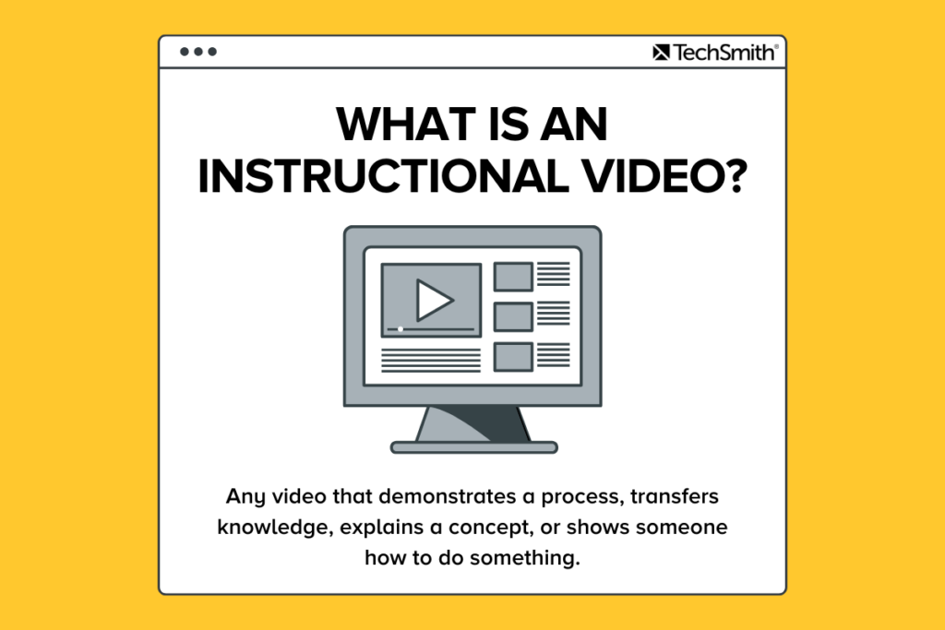

Here are some of the most common [types of instructional videos](https://www.techsmith.com/blog/types-of-instructional-videos/) you can create:

* [Microvideos](https://www.techsmith.com/blog/introduction-to-microvideo/) are short instructional videos that focus on teaching a single, narrow topic.
* [Tutorial videos](https://www.techsmith.com/tutorial-camtasia-how-to-make-a-video-tutorial.html) are the go-to instructional method for teaching a process or giving step-by-step instructions and are sometimes referred to as “how-to” videos.
* [Training videos](https://www.techsmith.com/blog/how-to-make-great-training-videos/) are designed to improve employees’ workplace skills and often use footage of real people to connect the trainer to the trainee.
* [Explainer videos](https://www.techsmith.com/blog/explainer-video/) explain a business concept or product in an entertaining, visual way. They’re usually short and help simplify complex ideas.
* [Recording a lecture or presentation](https://www.techsmith.com/blog/record-a-presentation/) can make that instructional content available for an audience to consume or review after the fact. These videos tend to be longer than tutorial videos and require a higher level of investment from your audience.
* [Screencasts](https://www.techsmith.com/blog/what-is-screencasting/) are quick, informal videos composed primarily of screen recordings designed to teach someone to perform a task or share knowledge.

As you can see, instructional videos go by various names, but the goal is the same.

Unlike other forms of video, an instructional video instructs. While you don’t want your videos to be boring, your main goal is for your viewers to comprehend and learn what you are teaching them.

**Common mistakes people make when creating videos**

When making instructional videos, people make a few common mistakes. Here are a few you can easily avoid:

**Mistake #1: Not knowing your audience**

If you don’t know your audience, it’s all but impossible to make a helpful video. Understanding who you are trying to help will guide critical decisions about your videos.

General information is helpful, but thinking about a specific individual who represents your audience – what their problems are, why they will be watching your video, what they like and don’t like – will help you make a more focused and detailed video.

We’ll go over more ways to get to know your audience later in this guide.

**Mistake #2: Trying to make your video perfect**

Too often, people worry about getting their videos perfect. It’s good to remember that perfect is an illusion. If you start with perfection in mind, it can paralyze your creative process, and you’ll struggle to get started.

Remember, the goal of creating an instructional video is to teach someone something, not create a perfect video.



***Punch perfectionism in the face. Punch fear in the face, and just hit publish, because you just got to put out your first videos, and the reality…is your first videos are going to be your worst videos. We all start horrible, and I think that’s the fear. We’re afraid of putting out some bad videos…just accept the fact they’re going to be bad, and get those ones out there.***

[*Sean Cannell, THiNKmediaTV*](https://www.youtube.com/thinkmediatv)

**Mistake #3: Worrying too much about equipment**

It’s easy to get overwhelmed and feel like you don’t have the right tools to create quality videos.

Having the latest and greatest gear is fun, but it’s not a necessity. Learn the basics, then start to upgrade your tools.

You do not need fancy equipment to make great videos, and we’ll prove it later in this guide when we show you the equipment we use to make great videos.



***So many people focus on ‘I don’t have the right gear’ and ‘I don’t have the right camera,’ but they don’t really think about, well, what is my message? What am I trying to get across with my brand? They don’t want to just be told, buy my product. If you can make someone feel something, if you can make them relate to what you’re doing, that’s more important than any piece of gear.***

[*Andrew Kan, YouTube video creator*](https://www.youtube.com/c/AndrewK?app=desktop)

**The best software for making instructional videos**

Finding the right tool for capturing your screen and editing your videos can be intimidating, especially if you’ve never made an instructional video before. There are a lot of options out there!

If you’re looking for a screen capture and video editing tool that is quick to learn and doesn’t require fancy video editing skills, we recommend [TechSmith Camtasia](https://www.techsmith.com/video-editor.html).

Camtasia is great for making any type of instructional video. Plus, we offer a ton of [helpful tutorials](https://www.techsmith.com/tutorial-camtasia.html) to get you started. Download a [free trial of Camtasia](https://www.techsmith.com/download/camtasia/) and hop right in!

**How to make an instructional video**

The secret to making a great instructional video is a well-thought-out plan. Taking the time upfront to develop a plan for your instructional video is critical to its success.

**Here are the essential steps to making a great instructional video:**

* [Step 1: Determine and get to know your audience](https://www.techsmith.com/blog/instructional-videos/#h-get-to-know-your-audience)
* [Step 2: Write a storyboard and script](https://www.techsmith.com/blog/instructional-videos/#h-write-a-storyboard-and-script)
* [Step 3: Record your narration](https://www.techsmith.com/blog/instructional-videos/#h-record-your-narration)
* [Step 4: Record your screen or capture video](https://www.techsmith.com/blog/instructional-videos/#h-record-your-video)
* [Step 5: Edit the video](https://www.techsmith.com/blog/instructional-videos/#h-edit-the-video)
* [Step 6: Add a video intro](https://www.techsmith.com/blog/instructional-videos/#h-add-a-video-intro)
* [Step 7: Share your video](https://www.techsmith.com/blog/instructional-videos/#h-share-your-video)

https://fast.wistia.com/embed/medias/2qprqdfmkn/swatch

Video Thumbnail

7:25

[How to Make Tutorial Videos | Camtasia | TechSmith](https://www.techsmith.com/tutorial-camtasia-how-to-make-a-video-tutorial.html?wvideo=2qprqdfmkn)

**Step 1: Determine and get to know your target audience**

Before you even think about hitting the record button, you need to know your target audience and understand why they need help.

If you have a product or service, talk to your customers about how they use your product and where they struggle.

If you’re teaching a class, find out what knowledge or skills your students hope to gain.

Are you training a new hire? Ask yourself what questions they might have and the information they need to succeed.

Then, use that information to choose tutorial topics that will help the most people.

WARNING: As tempting as it may be, DO NOT skip this first step. Even if you know your audience like the back of your hand, it’s still vital to put that information into an outline.

Before you move on to the next step, make sure you can answer these questions:

* **What is your topic?** Pick only one subject to cover per video, and your instructional video will be more focused and easier to create.
* **Who is your audience?** Start by determining demographic information, like education, age, professional organizations, etc. and then consider their interests, concerns, and goals.
* **Why does your audience care about this topic?** If you understand why your audience would watch the video, you can more easily address their concerns.
* **What is the learning objective of your video?** A clear learning objective helps you provide more straightforward instruction with a more achievable outcome.
* **How will your video benefit your audience?** What value will they take away if someone invests their time in watching your video?

We cover even more questions to consider when planning your instructional video in this clip from our [Video Workflow](https://www.techsmith.com/video-workflow.html) series.

https://fast.wistia.com/embed/medias/rwg6jon9u2/swatch

Video Thumbnail

29:55

Do you want more tips on creating videos? Watch the entire [Video Workflow](https://www.techsmith.com/video-workflow.html) series.

**Step 2: Write a storyboard and script**

Once you have a topic and know your audience, [create a storyboard](https://www.techsmith.com/blog/video-storyboard/) to outline and visualize what you plan to show.

Creating a storyboard ahead of time will help you make an instructional video that is clear, concise, and interesting to your audience.

Some people get creative and draw detailed pictures, but you don’t have to be an artist. Your storyboard can be as simple as this:

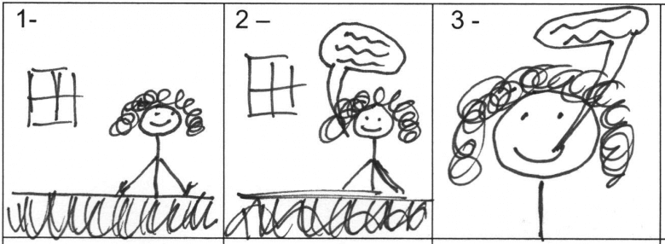

Quick sketches and stick figures are perfectly fine for live video. If you’ll be recording your screen to demonstrate a process, use a series of simple screenshots to show what you plan to display with the narration.

After storyboarding is done, it’s time to [write a script](https://www.techsmith.com/blog/how-to-write-script-for-video/).

Even a simple script will help you be more efficient, saving both yourself and your viewers time. Plus, you’ll also be far less likely to forget something.

It’s helpful to match your narration to what will be happening on screen during your video. If you were creating an instructional video about using the default calculator on a Mac, your script might look like this:

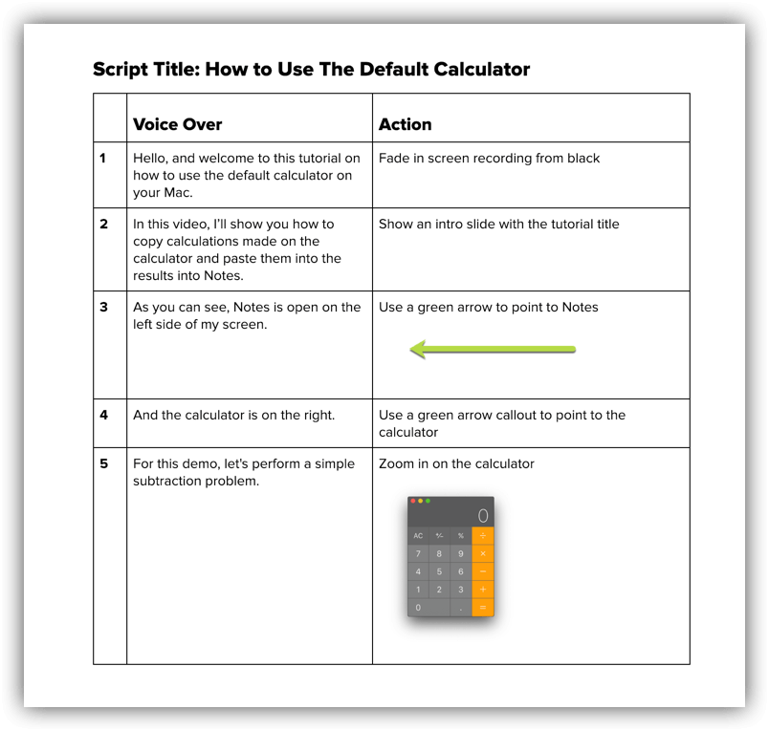

You don’t need to start with a blank page. Using a [general script template](https://www.techsmith.com/blog/how-to-write-script-for-video/) can help you write a successful script in less than 10 minutes.

https://fast.wistia.com/embed/medias/7maqnkfqrg/swatch

Video Thumbnail

29:51

Do you want more tips on creating videos? Watch the entire [Video Workflow](https://www.techsmith.com/video-workflow.html) series.

Here are a few more scriptwriting tips to help you get started:

* **Avoid jargon.** Using simple language as if you’re explaining the process to a friend will help make your script easier to follow.
* **Show AND tell.** Instead of simply giving a play-by-play of your onscreen actions, take time to explain both what you’re doing and why you’re doing it.
* **Practice, practice, and then practice some more.** Read your script aloud before you record. If you get tripped up, go back and make sure you’re using natural language.
* **Get feedback.** It might seem scary at first, but getting feedback during the scripting process will improve your instructional video and save you time later.

**Step 3: Record your narration**

With your script in hand, it’s time to [record the narration](https://www.techsmith.com/blog/voice-over/). Camtasia comes with a built-in, easy-to-use voice recording feature that is a great option. Still, you can take your voiceover and narration recording to the next level with [TechSmithAudiate](https://www.techsmith.com/audiate.html).

Audiate transcribes your voice in real time – as you record. This means you can edit your audio just as you edit the text in a document.

https://fast.wistia.com/embed/medias/oe296ahts0/swatch

Video Thumbnail

With Audiate, you don’t have to stare at a waveform all day to figure out exactly what you said and where. Audiate even automatically finds and deletes all of your “ums,” uhs,” and other hesitations for you.

Already have a voiceover recorded? Import it into Audiate, and the program will transcribe it for you.

You can save your edited audio file and import it right into Camtasia. You can even export the edited text as a transcript or SRT file for captions.

Even if you’re comfortable using professional audio recording software like Adobe Audition, Audiate is the best (and easiest) way to record voiceovers.

Next, get your hands on [the best microphone](https://www.techsmith.com/blog/what-microphone-is-best-for-recording-video/) you can find. Even a middle-of-the-road mic (like the one connected to your headphones) will provide much better sound quality than the one built into your computer.

https://fast.wistia.com/embed/medias/27yt6wffl7/swatch

Video Thumbnail

28:27

Do you want more tips on creating videos? Watch the entire [Video Workflow](https://www.techsmith.com/video-workflow.html) series.

Then, find a quiet place to record. TechSmith has a recording studio with sound dampening foam, but that isn’t feasible for everyone. A broom closet or small office can sometimes get you a pretty similar sound if you want a low-cost solution.

When you’re ready to hit record, make sure you speak slowly and clearly. If you make a mistake, don’t start over. Pause, then start again right before you made the mistake. You can remove any mistakes when you’re finished recording.

**Step 4: Record your video**

Depending on your instructional video’s topic, you might need to capture a recording of a process happening on your screen, demonstrate something in real life, or both.

**Recording your screen for an instructional video**

First, clean up your computer screen and close any unnecessary applications. Turn off notifications that might pop up before you start recording. Follow [these directions to get a crisp, clear screen video](https://www.techsmith.com/tutorial-camtasia-getting-crisp-clear-screen-video.html).

Then, open the application you want to record and conduct a few practice walkthroughs of exactly what you want to show your viewers. This practice will help you get smooth cursor motions, and you’ll have less editing to do in the end.

After a few run-throughs, open the Camtasia recorder and [capture your screen](https://www.techsmith.com/blog/record-your-desktop/) just as you practiced. Remember, if you make a mistake, pause and start again from that point. You’ll be able to smooth things out when editing later on.

**TIP:** When you choose a [screen capture](https://www.techsmith.com/screen-capture.html) or [screencasting software](https://www.techsmith.com/video-editor.html), pick a tool with built-in recording, editing, and sharing features. It will save you time and let you do all of your work in one tool.

If you want a simple way to increase engagement and help viewers connect with your content, try adding a [webcam recording](https://www.techsmith.com/blog/how-to-webcam-recorder/) to your screencast.

**Recording an instructional video with a camera**

There are a lot of similarities between recording your screen and creating a training video with a camera. You still need a plan, a script, and the right tools, but stepping in front of the camera brings new challenges.

https://fast.wistia.com/embed/medias/a38vx5vv2k/swatch

Video Thumbnail

4:10

Here are a few things to consider when creating an instructional video that includes camera video:

* Don’t get overwhelmed by equipment. In the video above, we only used five tools: a tripod, smartphone, phone clip, a clean backdrop, and lights.
* Make sure your [recording space](https://academy.techsmith.com/basics-setting-up-to-shoot-video) is well-lit. You’ll either want to record in an area with a lot of natural light or add some [video lighting](https://www.techsmith.com/blog/get-perfect-lighting-video/) to your equipment list.
* Place your camera on a tripod, and position it as close to your subject as possible while still getting everything you need in the shot. Being close to the subject will help you get the best possible audio when recording with a smartphone camera.

**Step 5. Edit the video**

Most people feel like they need to be a professional video editor to make a nice-looking video, but the truth is that you don’t need expensive editing tools or a lot of knowledge to get started.

**Recommended Viewing:** [How to Edit Video](https://www.techsmith.com/blog/edit-video/)

In Camtasia, you can cut out mistakes by [selecting them with the playhead](https://support.techsmith.com/hc/en-us/articles/360003183692), then clicking cut. To trim extra footage from the ends of your recording, drag the end of the clip in.

Add your audio narration to the timeline when you finish editing your video. You can use clip speed and extend frame to sync the audio and video in your project.

https://fast.wistia.com/embed/medias/ybc2jbdbdm/swatch

Video Thumbnail

4:05

[Editing In-Depth | Camtasia | TechSmith](https://www.techsmith.com/tutorial-camtasia-editing-in-depth-1.html?wvideo=ybc2jbdbdm)

Here are some [simple video editing tips](https://www.techsmith.com/blog/50-tips-better-video/) to improve your instructional videos:

* If you need more time explaining a concept, split the clip and [use extend frame](https://www.techsmith.com/tutorial-camtasia-ripple-move-and-extend-frame.html) to freeze the video.
* To speed up a boring part of your recording, [add clip speed](https://support.techsmith.com/hc/en-us/articles/360003407252-Change-the-Clip-Speed), then drag the handles to speed it up.
* Add interactive elements like [callouts, arrows, shapes, lower thirds, or sketch motions](https://www.techsmith.com/learn/tutorials/camtasia/annotations/) to highlight key points in your video.

[Adding music to your video](https://www.techsmith.com/blog/tutorial-video-music/) isn’t required, but can take a good video to the next level. Choose something upbeat. You want your viewers to feel good as they’re learning.

https://fast.wistia.com/embed/medias/kzkq003gbt/swatch

Video Thumbnail

0:10

[Ripple Move & Extend Frame | Camtasia | TechSmith](https://www.techsmith.com/tutorial-camtasia-ripple-move-and-extend-frame.html?wvideo=kl618a17km)

**Step 6. Add a video intro**

Use a video intro to lead viewers into your content, but don’t get too crazy. Keep your opening simple and to the point.

Viewers want to get to the substance of your video. They don’t care about anything other than what you promised to teach them.

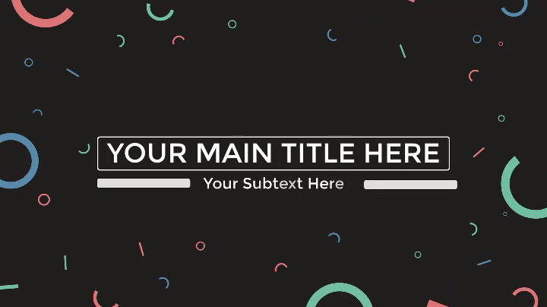

A good intro clearly lays out the topic and quickly explains what viewers can expect to learn.

To create your own video intro in Camtasia, you will need to add some space at the beginning of your video. Hold the shift key on your keyboard and drag the playhead to the right.

Then, open the media bin and select the Library tab. From the “Motion Graphics – Intro Clips” folder, drag the intro you like onto the timeline.

Camtasia comes stocked with a few built-in video intro templates, but you can get an entire catalog of pre-made video assets, including intro templates from [TechSmith Assets](https://www.techsmith.com/assets.html).

You can customize your intro clip [by selecting it on the timeline and then editing the text and shapes in the properties panel](https://www.techsmith.com/tutorial-camtasia-themes.html). Enter text, choose a font, and change any colors or other settings for the shapes and text.

**Step 7: Share your video**

Finally, think about where your video will live. There are many [video hosting options](https://www.techsmith.com/blog/instructional-videos/#:~:text=video%20hosting%20options) to choose from these days.

You can share your video directly to online video platforms like YouTube, Vimeo, or [Screencast](https://www.techsmith.com/screencastcom.html) in Camtasia or save the video as a local file to upload on social media.

There are many reasons to share your [education and learning videos on YouTube](https://www.techsmith.com/blog/youtube-for-learning-videos/). Plus, we have a free guide with tips and tricks on [how to make a YouTube video](https://www.techsmith.com/blog/make-youtube-video/).

Before sending your video out into the world, share it with a few people to get some [video feedback](https://www.techsmith.com/blog/get-video-feedback/). This input helps ensure your message is clear, and that your video accomplishes your goals.

**The actual cost of making tutorial, training, and explainer videos**

Before you roll up your sleeves DIY style or hand off your project to a professional video company, let’s take a step back and make sure the right people are making your video.

Budget often plays a significant role in this decision. Start by considering the impact you want the video to have.

Here are a few questions to ask when weighing the options:

* How many videos do I need?
* How much money am I willing to spend?
* Is this video going to lead the marketing efforts for a campaign?
* Will this video live in a prominent place, such as on a website landing page?

Below, I’ve laid out the pros and cons of common options for creating an instructional video.

**Hire an outside company**

If a lot depends on this video, you might want to consider hiring an external company to produce a “knock their socks off” level video.

But buyer beware. This option will cost you a lot of time and money. Furthermore, if you want to edit the video further for use in other places, you’ll have to pay extra for that.

**Pros:**Video production companies have the talent, skills, and experience to create the best explainer videos. Good companies work with you to make your video exactly how you want it.

**Cons:**The average cost for a custom 60-second explainer video is roughly $8,000, and just one professionally-made tutorial video can cost $10,000 or more.

**Make your own videos**

Creating your videos in-house gives you more control over the budget and complete creative freedom. A screencast tool like Camtasia is perfect if you’re looking for a DIY option.

**Pros:** You have complete creative freedom and more control over the budget.

**Cons:** You can be limited by your skills, time, and resources when going the DIY route.

While you may never reach the level of a full-time video producer, you’ll be amazed at the quality of the videos you can create with just a little bit of practice.

**What’s next?**

Whether you’re just getting started or a video pro, you’ve learned some of the key tools and strategies to create successful videos.

Take this guide, [download a free trial of Camtasia](https://www.techsmith.com/video-editor.html), and get started.

Do you want to learn even more about creating videos? Head over to the [TechSmith Academy](https://academy.techsmith.com/). It’s a free resource designed to level-up new video creators.

**No time to read the whole guide?**

Don’t worry. Get a **free PDF version** so you can read it whenever you want.

[Download PDF](https://discover.techsmith.com/training-instructional-video-guide/)

**Frequently asked questions**

**How long should instructional videos be?**

According to TechSmith research, most viewers prefer videos of 1-6 minutes in length. However, there is also an appetite for longer videos of up to 20 minutes. It all depends on your topic and audience. In some cases, a longer video may be more successful.

**How do you make a training video?**

You can make a [training video](https://www.techsmith.com/blog/how-to-make-great-training-videos/) with a camera, screen recorder, and video editor. Just make sure you plan out your content first and know exactly who the audience is for your video.

**What is the best software for making video tutorials?**

TechSmith Camtasia is the best software for making tutorial videos. It’s simple to use, but flexible enough to take on larger projects down the road.

**What are video tutorials?**

Video tutorials are the go-to instructional method for demonstrating a process or providing step-by-step instructions. They’re usually between 2-10 minutes long and may leverage multiple instructional methods.

**Can streaming video be recorded?**

Absolutely! You can easily capture or [record live streaming video](https://www.techsmith.com/blog/record-live-streaming-video/) and share it with your friends, your coworkers, or save it for later viewing. It’s easy, it’s fast, and it will bring order to a chaotic media landscape.

*Editor’s Note: This post was originally published in February 2019 and has been updated in February 2022 for accuracy and to include new information.*

* [**CAMTASIA**](https://www.techsmith.com/blog/category/camtasia/)

* [**VIDEO**](https://www.techsmith.com/blog/category/video/)

[](https://www.techsmith.com/blog/author/d-ezelltechsmith-com/)

**[DANIELLE EZELL](https://www.techsmith.com/blog/author/d-ezelltechsmith-com/)**

Marketing Content Specialist at TechSmith

* [How to Run More Effective Meetings with Async Video](https://www.techsmith.com/blog/video-based-discussions/)
* [Here's the Best Way to Quickly Take a Scrolling Screenshot](https://www.techsmith.com/blog/scrolling-screenshot/)
* [Proximity Bias and Hybrid Work: What You Need to Know](https://www.techsmith.com/blog/proximity-bias/)

**Subscribe to TechSmith’s Newsletter**

Join over 200,000 people who get actionable tips and expert advice every month in the TechSmith Newsletter.

[**Subscribe**](https://www.techsmith.com/emailpreferences/)

* [**Products**](https://www.techsmith.com/products.html)
* [Snagit](https://www.techsmith.com/screen-capture.html)
* [Camtasia](https://www.techsmith.com/video-editor.html)
* [Assets for Camtasia](https://library.techsmith.com/camtasia)
* [Assets for Snagit](https://library.techsmith.com/snagit)
* [Knowmia](https://www.techsmith.com/knowmia-education.html)
* [Screencast](https://www.techsmith.com/screencastcom.html)
* [Audiate](https://www.techsmith.com/audiate.html)
* [Video Review](https://www.techsmith.com/video-review.html)
* [Jing](https://www.techsmith.com/jing-tool.html)
* [Screen Recorders](https://www.techsmith.com/screen-recorder.html)
* [**Solutions**](https://www.techsmith.com/solutions.html)
* [Employee Training](https://www.techsmith.com/employee-training.html)
* [Customer Education](https://www.techsmith.com/customer-training-onboarding.html)
* [Higher Education](https://www.techsmith.com/education.html)
* [Enterprises](https://www.techsmith.com/business.html)
* [**Support**](https://www.techsmith.com/help.html)
* [Find Software Key](https://www.techsmith.com/about-techsmith-id.html)
* [Tutorials](https://www.techsmith.com/tutorial.html)
* [Help Center](https://support.techsmith.com/)
* [Community Forums](https://feedback.techsmith.com/techsmith)
* [Email Preferences](https://www.techsmith.com/emailpreferences/)
* [Webinars](https://www.techsmith.com/webinars.html)
* [**Resources**](https://www.techsmith.com/company.html)
* [Blog](https://www.techsmith.com/blog/)
* [TechSmith Academy](https://www.techsmith.com/academy.html)
* [Customer Stories](https://www.techsmith.com/customer-stories.html)
* [Press Room](https://www.techsmith.com/press.html)
* [Partners](https://www.techsmith.com/partner-information.html)
* [Research](https://www.techsmith.com/visual-communication-research.html)
* [**About**](https://www.techsmith.com/about.html)
* [About Us](https://www.techsmith.com/about.html)
* [Contact Us](https://www.techsmith.com/contact.html)
* [Careers](https://www.techsmith.com/careers/)
* [**Store**](https://www.techsmith.com/products.html)
* [Find a Reseller](https://www.techsmith.com/application/salescontact/resellers)
* [Online Store FAQ](https://support.techsmith.com/hc/en-us/sections/360003910011-Purchasing-and-Invoicing)
* [Payment Options](https://support.techsmith.com/hc/en-us/articles/360025167172)
* [Return Policy](https://support.techsmith.com/hc/en-us/articles/203732668)

You Should Stay In Touch!

* [Privacy](https://www.techsmith.com/privacy.html)

* [Accessibility](https://www.techsmith.com/accessibility.html)

* [Contact](https://www.techsmith.com/contact.html)

* [Sitemap](https://www.techsmith.com/sitemap.html)

© 1995 - 2022, TechSmith Corporation, All Rights Reserved.

* [English](https://www.techsmith.com/learn/instructional-videos/)
* [Deutsch](https://www.techsmith.de/learn/instructional-videos/)
* [Français](https://www.techsmith.fr/learn/lessentiel-a-connaitre-pour-realiser-une-video-tuto/)
* [Español](https://www.techsmith.es/learn/videos-tutoriales/)